**LIT ASSIGNMENT**

**Day - 12**

**Emp Id : 46255242**

**Name : Vani Vemireddy.**

**Q1: Adobe form to display flight booking details**

**Table type:**

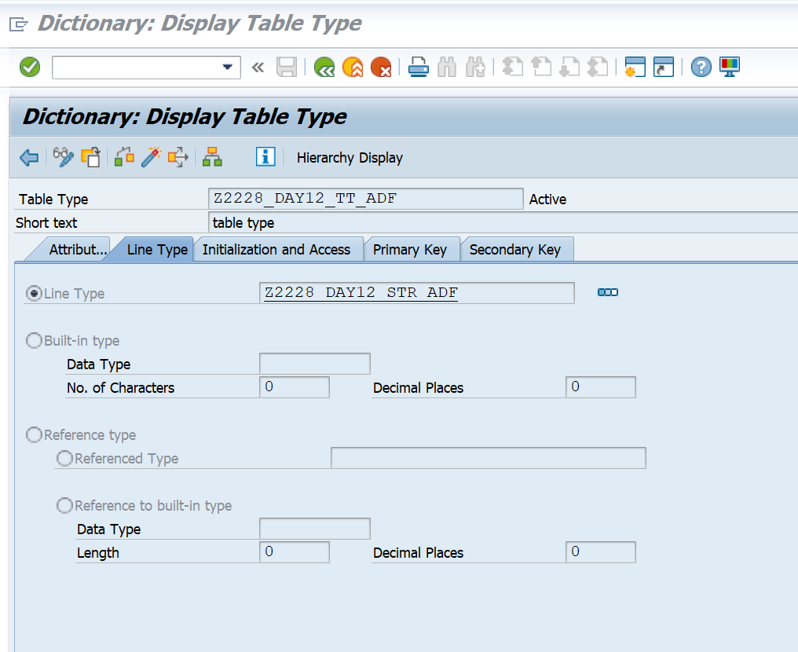

**Structure:**

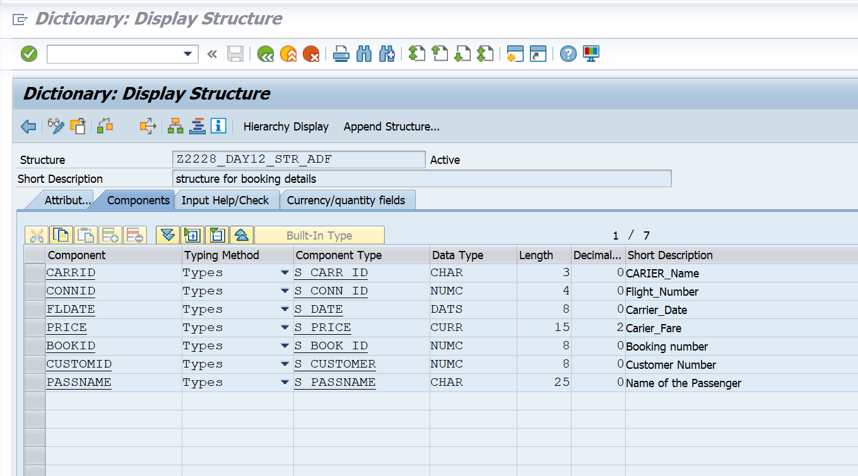

**Interface:  Tcode -SFP**

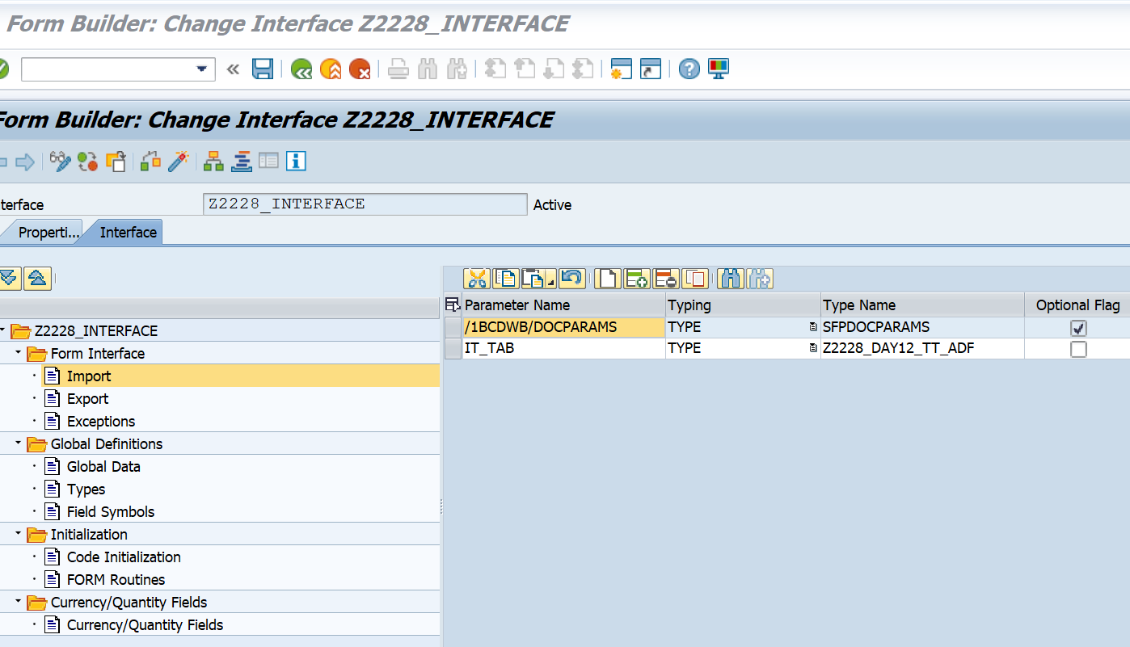

**Context:**

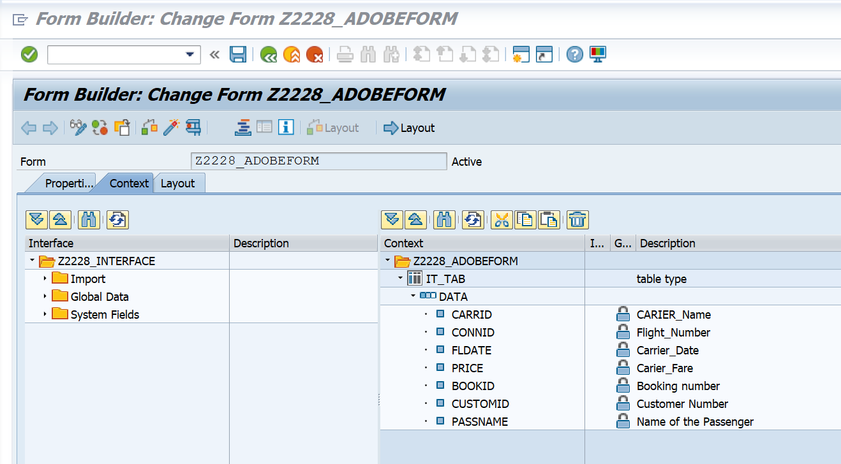

**Form Layout:**

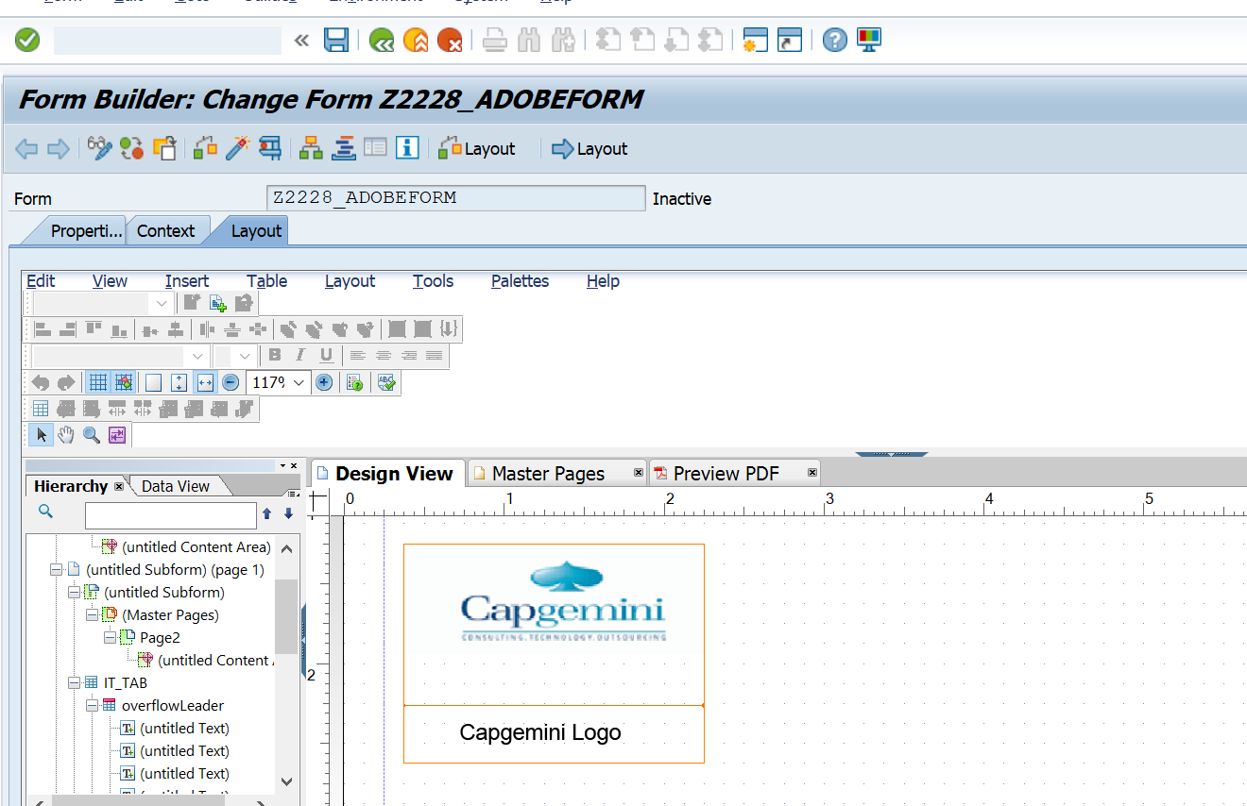

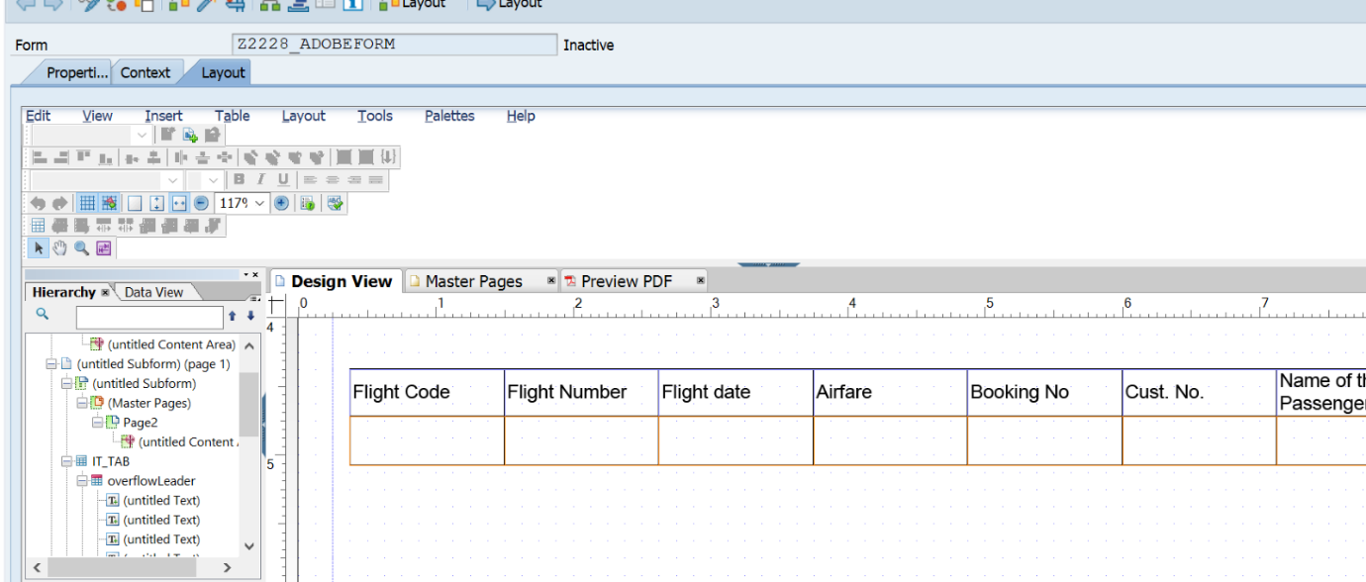

**Program:**

REPORT Z2228_ADOBEFORMS.   
   
tables : sflight ,spfli, sbook.   
   
data it_tab type standard table of Z2228_DAY12_STR_ADF.   
   
DATA  wa_oparams type sfpoutputparams.   
   
   
SELECT-OPTIONS : s_carrid FOR spfli-carrid.   
 SELECT spfli~carrid   
       spfli~connid   
       sflight~fldate   
       sflight~price   
       sbook~bookid   
       sbook~customid   
       sbook~passname   
FROM spfli INNER JOIN sflight   
ON spfli~carrid EQ sflight~carrid   
INNER JOIN sbook   
ON spfli~carrid EQ sbook~carrid   
UP TO 10 ROWS       *"selecting fields from SPFLI , SFLIGHT and SBOOK*   
INTO TABLE it_tab                                                    *"into internal table*   
WHERE spfli~carrid IN s_carrid.   
   
CALL FUNCTION 'FP_JOB_OPEN'   
  CHANGING   
    ie_outputparams       = wa_oparams   
*\* EXCEPTIONS*   
*\*   CANCEL                = 1*   
*\*   USAGE_ERROR           = 2*   
*\*   SYSTEM_ERROR          = 3*   
*\*   INTERNAL_ERROR        = 4*   
*\*   OTHERS                = 5*   
          .   
IF sy-subrc <> 0.   
*\* Implement suitable error handling here*   
ENDIF.   
   
CALL FUNCTION '/1BCDWB/SM00001200'   
  EXPORTING   
*\*   /1BCDWB/DOCPARAMS        =*   
    it_tab                   = it_tab   
*\* IMPORTING*   
*\*   /1BCDWB/FORMOUTPUT       =*   
*\* EXCEPTIONS*   
*\*   USAGE_ERROR              = 1*   
*\*   SYSTEM_ERROR             = 2*   
*\*   INTERNAL_ERROR           = 3*   
*\*   OTHERS                   = 4*   
          .   
IF sy-subrc <> 0.   
*\* Implement suitable error handling here*   
ENDIF.   
   
   
CALL FUNCTION 'FP_JOB_CLOSE'   
*\* IMPORTING*   
*\*   E_RESULT             =*   
*\* EXCEPTIONS*   
*\*   USAGE_ERROR          = 1*   
*\*   SYSTEM_ERROR         = 2*   
*\*   INTERNAL_ERROR       = 3*   
*\*   OTHERS               = 4*   
          .   
IF sy-subrc <> 0.   
*\* Implement suitable error handling here*   
ENDIF.

**Output:**



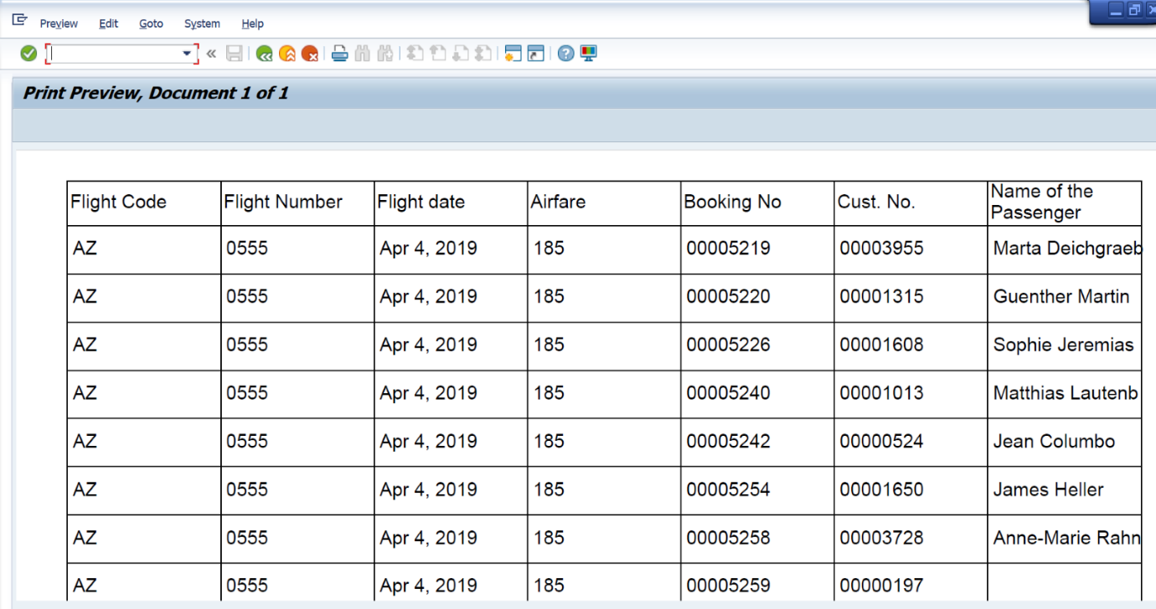

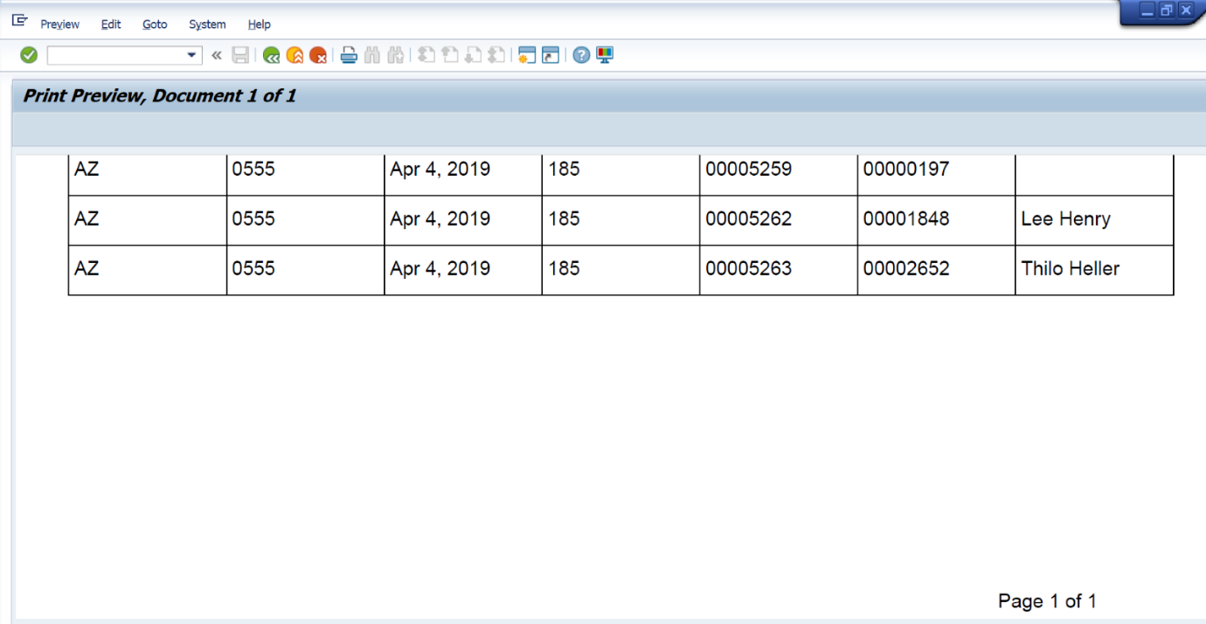

**Q2:  Java Script to display footer only last page**

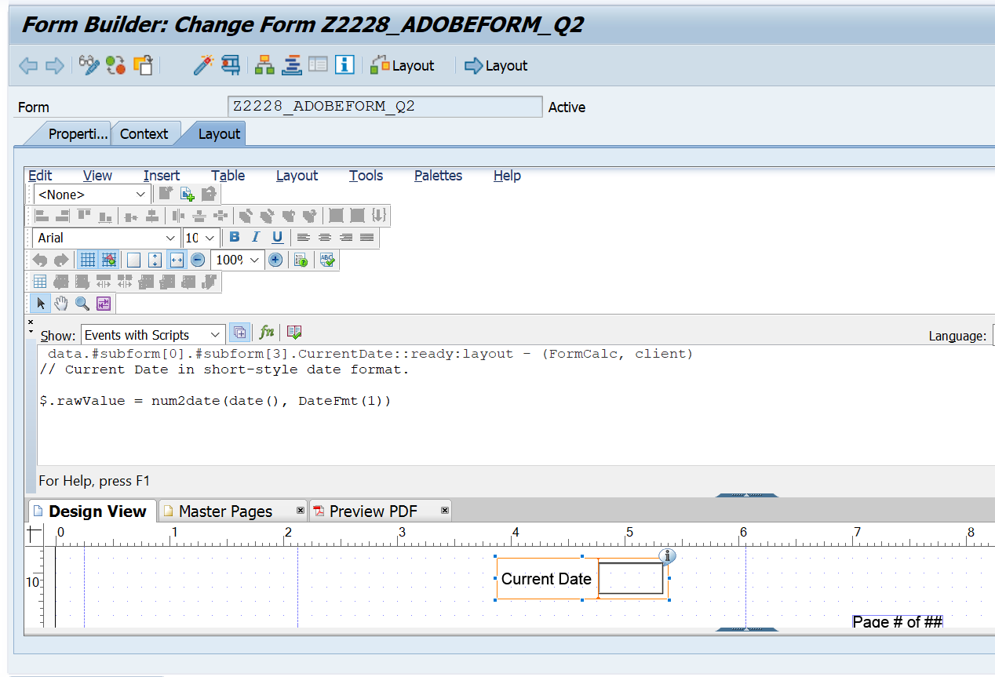

**Output:**



**Q4: Dynamic text in Adobe form**

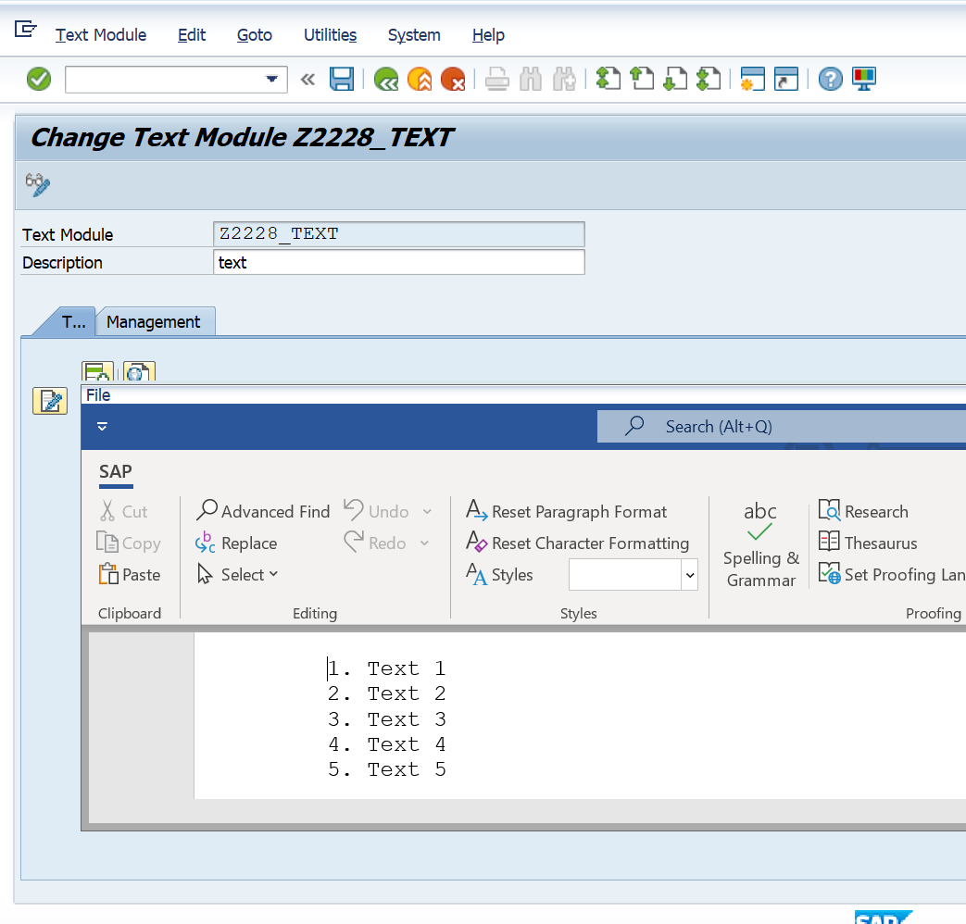

**Context:**

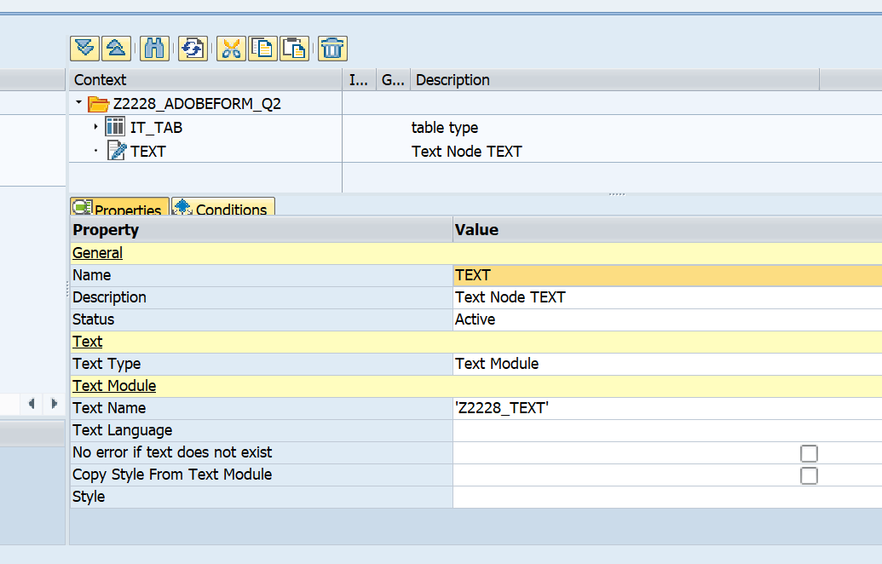

**Layout:**

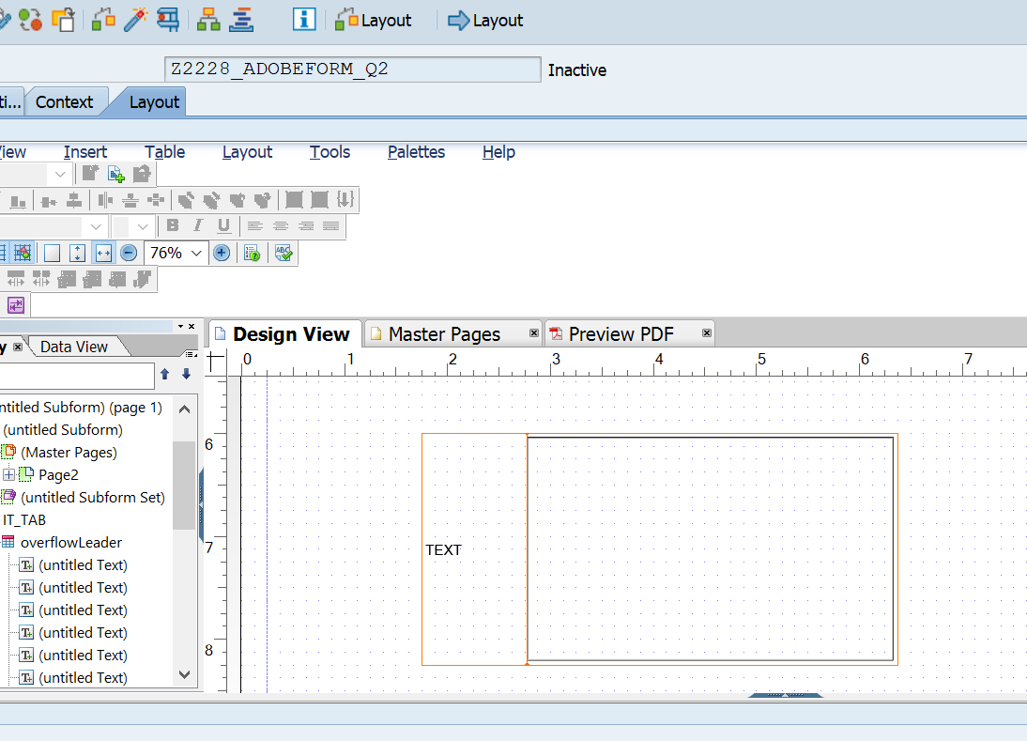

**Output:**

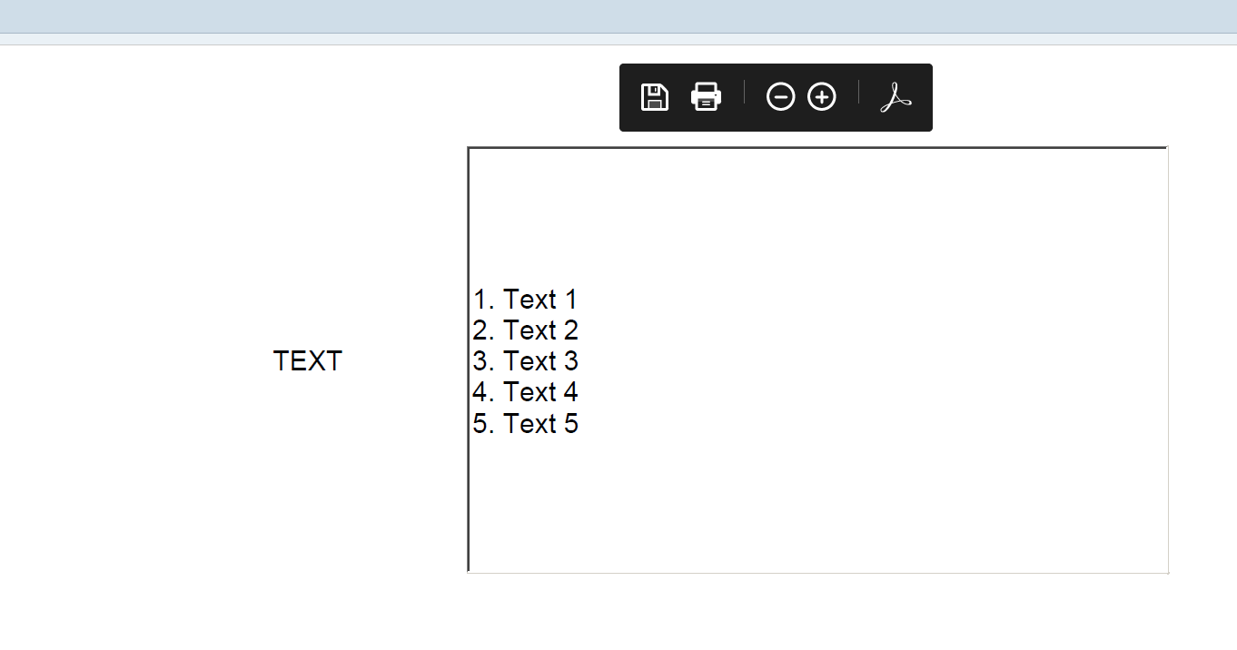

**Q5: Include test**

**Table type:**

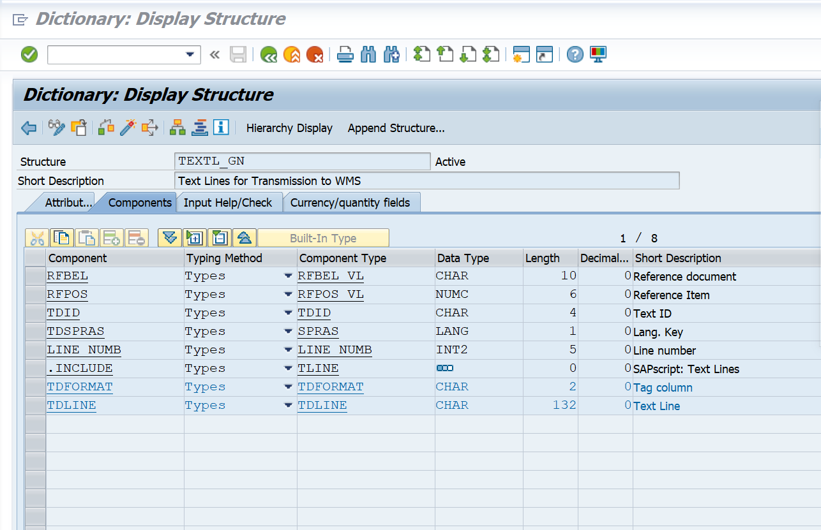

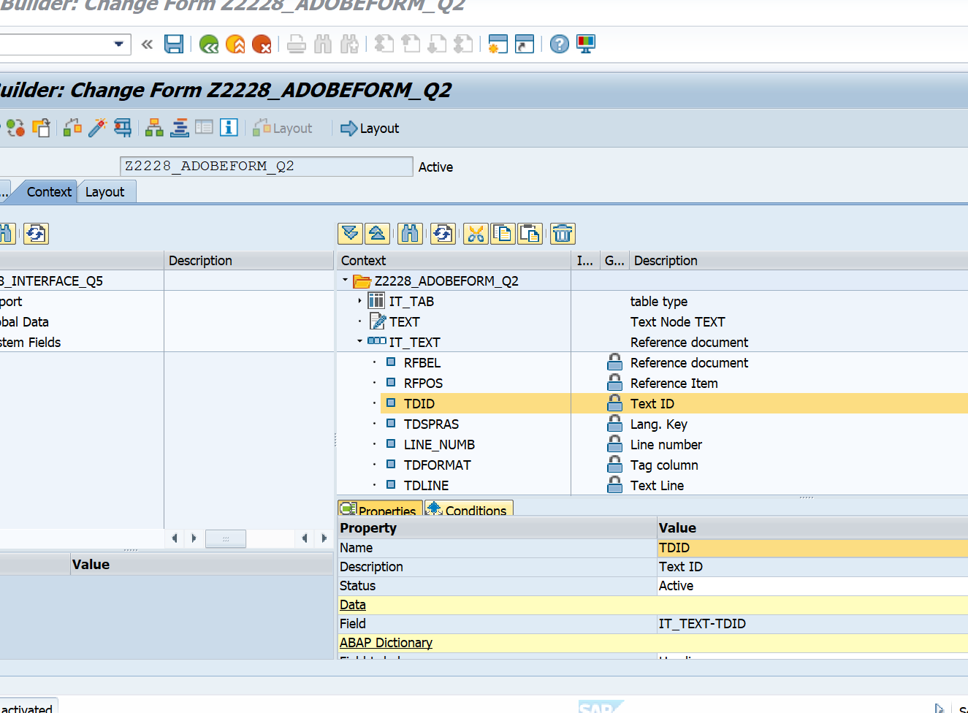

**Layout:**

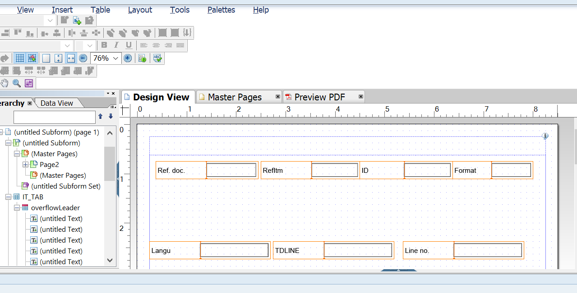

**Output:**

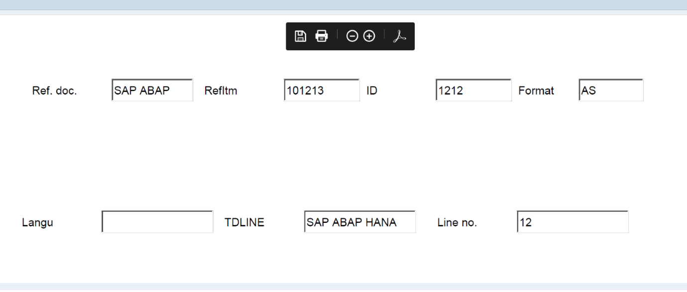

**Capgemini logo using SE78:**

**Form Interface:**

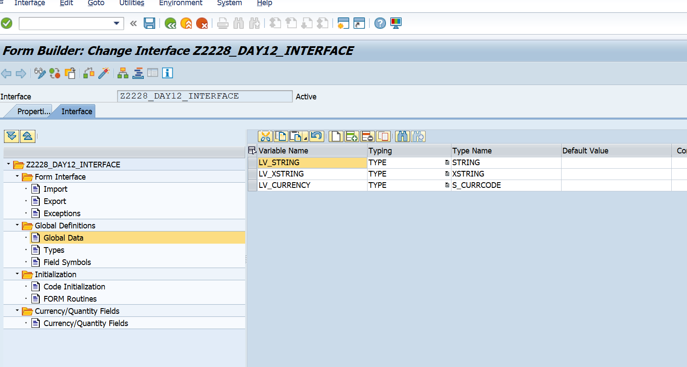

**Code Initialization:**

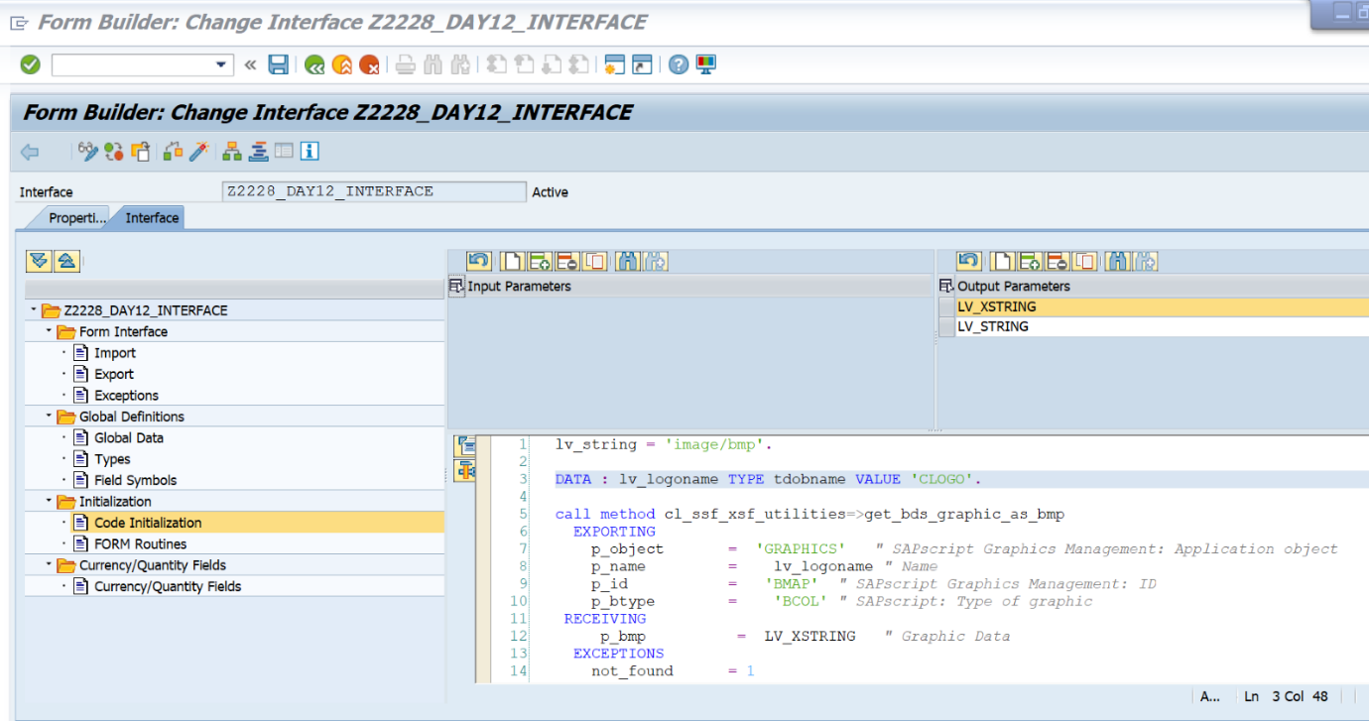

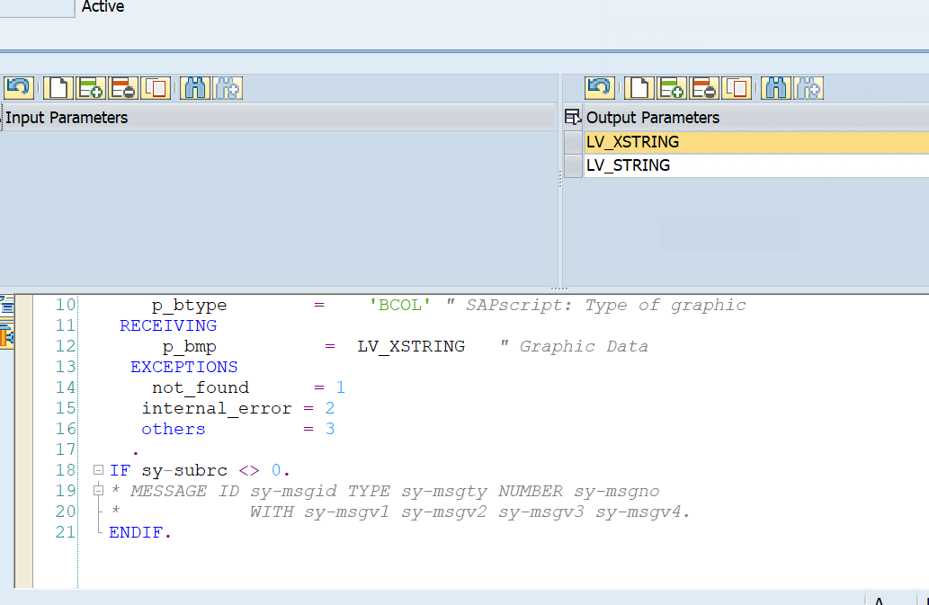

**Form Layout:**

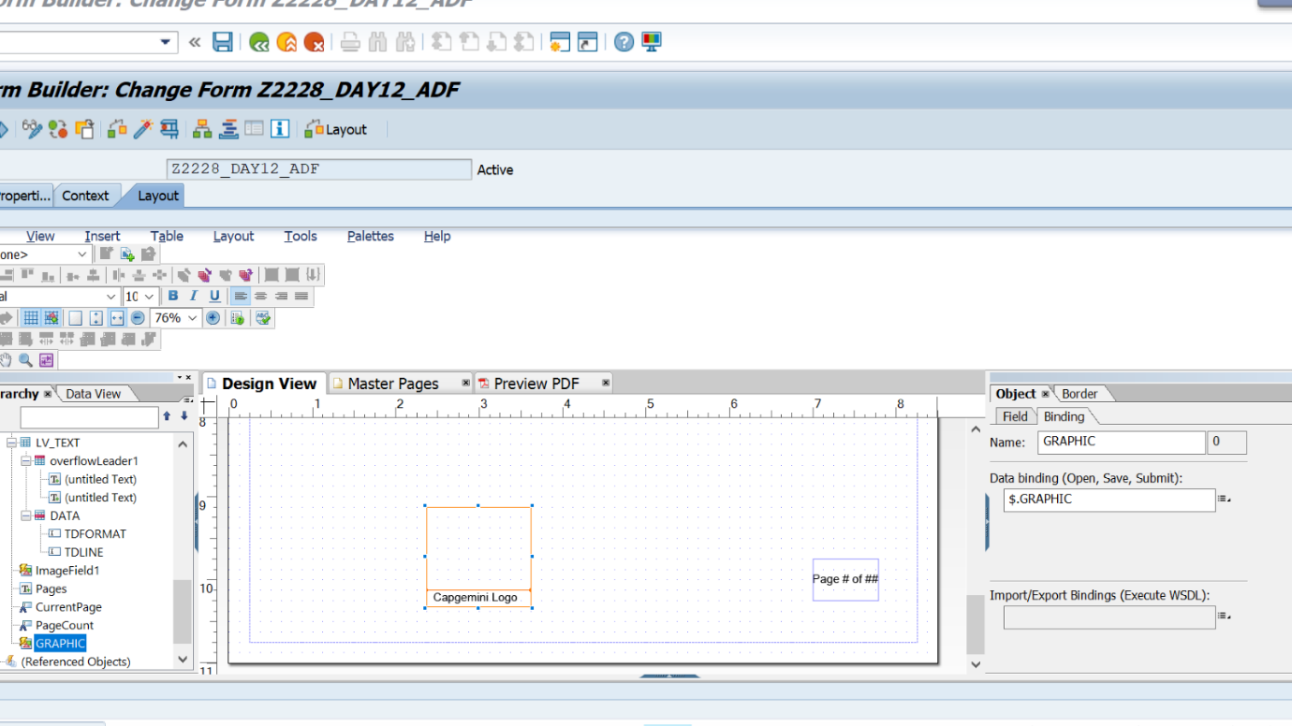

**Output:**

